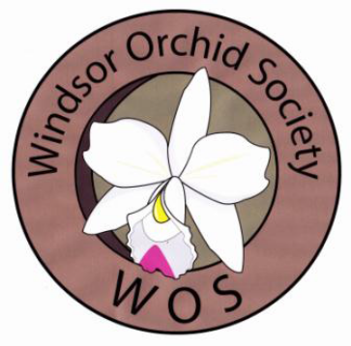
The Windsor Orchid Society
Orchid Show
“Fall for Orchids”

St. Cyril’s Slovak Centre
1520 Chandler Rd., Windsor, ON N8Y 4P7

October 20st & 21st, 2018

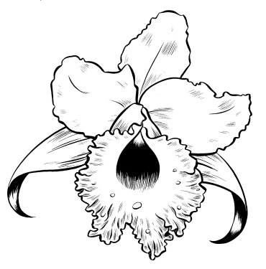
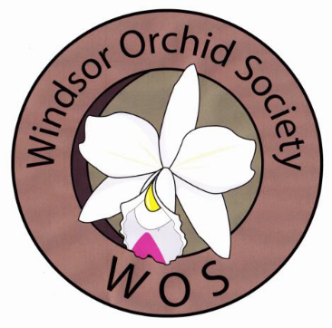
WINDSOR ORCHID SOCIETY
Fifth ANNUAL ORCHID SHOW
October 20-21, 2018
St. Cyril’s Slovak Centre
1520 Chandler Rd., Windsor, ON N8Y 4P7

SCHEDULE OF EVENTS

Friday, October 19, 2018

12:00 p.m. Setup for sales and displays begins
and Plant registration opens (no earlier please)
6:00 p.m. Food and Refreshments
8:00 p.m. Registration closes
9:00 p.m. Setup ends and building is secured

Saturday, October 20, 2018

7:15 a.m. Judges’ and clerks’ light breakfast
8:00 a.m. Ribbon judging starts
AOS judging starts after ribbon judging
11:00 a.m. Exhibit and Sales areas open to public
Noon – 1:00 p.m. Judges’ luncheon
1:00 p.m. AOS judging resumes
5:00 p.m. Show closes; building is secured
6:30 p.m. Optional dinner for participants
(each participant responsible for their own bill)

Sunday, October 21, 2018

9:00 – 11:00 a.m. Photographers’ Session and Workshop
11:00 a.m.- 4:00 p.m. Show and sales open to public
11:30 p.m. Orchid growing presentation
1:00 p.m. Orchid growing presentation
2:30 p.m. Orchid growing presentation
4:15 p.m. Takedown (when announcement is made)
2018-19 WINDSOR ORCHID SOCIETY
Executive

President Ed Cott
Vice President Deb Boersma
Past President Deb Boersma
Secretary Renee Gignac
Assistant Secretary Eunice Bragg
Treasurer Kathleen Fekete

2018 SHOW COMMITTEE

Show Chair Ed Cott
Vice Chair Deb Boersma
Judging Chair Terry Kennedy
Judging and Clerking Liaison Ed Cott
AOS Photographer Ed Cott
Venue Liaison Ed Cott and Scott Hitchen
WOS Exhibit Mark Whelan
Art & Photography Chair Ed Cott and Scott Hitchen
Show Treasurer Kathleen Fekete
Hospitality Renee Gignac
Information Table/Membership Eunice Bragg
Ribbons and Awards Eunice Bragg
Betty Levar
Registration and Website Adele Beitler
Publicity Chair Deb Boersma
Fund-Raising Chair empty
Staging Scott Hitchen/Ed Cott
Vendor and Exhibitor Liaison Ed Cott

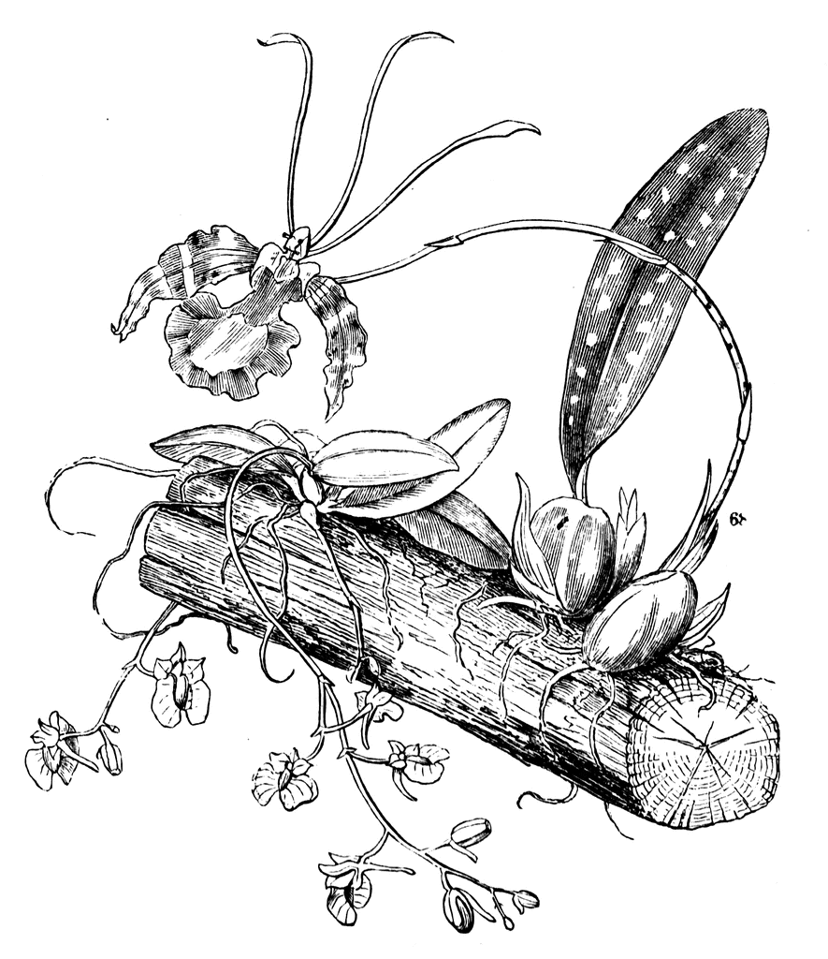
SHOW RULES AND REGULATIONS

- The Windsor Orchid Society (WOS) Show will be held at St. Cyril’s Slovak Centrer, in Windsor, Ontario on October 20-21, 2018. Exhibitor and Vendor set up will take place on Friday, October 19, 2018 starting no earlier than 12 noon.

- Exhibit space should be requested by application to the Show Chair (application available on the WOS website if not received by e-mail - www.windsororchidsociety.ca/orchid-show-2018.html) in accordance with the deadlines provided in the invitation.

- Every reasonable effort will be made to provide the amount of space requested on a first-come, first-served basis. Should available space be less than requested, you will be advised by the Show Committee.

4. Exhibit setup: Friday 12:00 noon to 9:00 p.m.
Registration: Friday 12:00 noon to 8:00 p.m.
Subsequent entries may be exhibited but not registered and will not be judged. All times noted are Eastern Daylight Time.

We request that all exhibitors be on-site by 6pm, time and space for late arrivals will be compromised otherwise.

5. Advertised show hours: Saturday 11:00 a.m. to 5:00 p.m. Public
Sunday 9:00 a.m. to 11:00 a.m. Photographers
Sunday 11:00 a.m. to 4:00 p.m. Public

6. All exhibits, including art (unless sold) and orchids in use, must be left in place until the announcement of the closing of the show on Sunday, October 21. An announcement will be made at 4:00 p.m. for the official closing of the show. Once the remaining visitors have been cleared from the hall, a second announcement will be made to begin takedown.

EXHIBITION GUIDELINES

7. All exhibitors are expected to familiarize themselves with and abide by the Rules and Regulations in this Show Schedule.

8. Participation in the Show by commercial vendor, society, or individual is by WOS invitation. A letter requesting participation may be sent to the Show Chair (laelia@aol.com).

9. Each exhibitor agrees upon entry to abide by the rules and regulations of the Show. All questions regarding the interpretation or application of these rules shall be referred to the Show Chair.

10. All exhibits are expected to be of a quality expected of an AOS Orchid Exhibit. The Show Chair reserves the right to remove inferior exhibits or plants, including those with insect infestations. All possible care and precautions will be taken but the WOS will not accept any liability for damages.

11. There are no fees to the exhibitor for entries or assistance in setting up exhibits.

12. Tables for exhibits will be furnished without cost, if requested in advance. All backdrops, cloths for tabletops, lighting, etc. must be furnished by the exhibitor.

13. Foliage plants, moss etc. may compliment exhibits, but no artificial or dyed moss or foliage will be permitted with the exception of artificial grass used as a floor covering.

14. Plants in flower or cut flowers other than orchids will not be permitted in an exhibit. No dyed flowers will be permitted. For floral arrangements, see Rules for Orchids in Use.

15. All lighting is to be provided by the exhibitor. Please request the need for an electrical plug at time of exhibit registration.

16. The WOS will provide all cards and signs displaying exhibitors’ names in the main display and exhibit area. No other identification will be permitted except as provided by the vendors in the sales area.

17. No sales tables shall be allowed in the exhibit area. Any plants sold which are part of an exhibit shall not be removed from the exhibit before the official close of show on Sunday.

18. Vendors wishing to sell plants or products during the show must have an exhibit in the show. That exhibit should be worthy of an AOS judged show. Vendors whose exhibits are not of suitable quality may be assessed an additional fee of $500. All plants sold must be properly labeled with genus and grex.
19. Neither the WOS nor St. Cyril’s Slovak Centre is responsible for loss or damage to any plants, blooms, corsages, containers, or other property of exhibitors. However, precautions will be exercised for their safety.

REGISTRATION AND CLASSIFICATION
CLASS FOR NOVICE GROWERS*
*A NOVICE GROWER is defined as a grower who has never won a ribbon or trophy at an orchid show for an exhibited orchid. The novice must have grown the plant for at least six (6) months. Any novice plant, being registered as such, is included in the one class; eg. any novice grown Cattleya or Oncidium or Paphiopedilum is entered in class 103 . PLEASE ASK FOR ASSISTANCE IF YOU ARE UNSURE.

20. Improperly entered plants/exhibits may be either reclassified or disqualified at the discretion of the judges.

21. In general, plants should be entered in the first applicable class. If in doubt, see the Registration Chair and refer to the Mid-America Classification Schedule.

22. There is no limit to the number of plants entered by one exhibitor in any one class.

23. If a plant is a meristem/mericlone flowering for the first time, it should be so designated and the clonal name given, if known. Separate classes have been designated for seedlings and for meristem/mericlones flowering for the first time. [See show schedule class 101]

24. For purposes of this schedule, the word "hybrid" means a cross made within the genus listed, unless preceded by the word "intergeneric", in which case, two or more different genera are used in the cross.

25. The appropriate class for intergeneric hybrids shall be the first class for intergeneric crosses which lists one of the genera making up the hybrid. (See lists of genera belonging to each class at the registration desk).

26. Natural hybrids should be included in species classes.

27. An exhibit cannot be entered in more than one class.

28. Individual plants or cut flowers cannot be entered in more than one class, with the exception of class 102.

29. In determining colour for a class, the following guidelines will be employed:
• two-tone flowers, or those where a primary base colour is indeterminable, should be entered in the "other colours" classification
• colour in Paphiopedilum hybrids is based on the dominant flower colour.

30. Criteria employed in ribbon class definitions refer to characteristics prevailing for mature plants grown according to normal horticultural practices.

ENTRY OF PLANTS AND EXHIBITS

31. Print legibly on the entry forms.

32. Procedure for entries:

• Registration of plants is facilitated if entries have been filed online or e-mailed prior to the on-line registration closing time and date. Registration forms will also be available at the Registration desk during registration on Friday.

• On each registration form indicate the CLASS NUMBER for each entry. Check the show schedule for the correct class. It is your responsibility to classify your entries correctly. Incorrect entries may be reclassified or disqualified at the discretion of the Judging Team Captain.

• Under NAME indicate the name of the plant, flower, or exhibit.

• For hybrids, add the parentage if known. Check the OrchidWiz data base, or similar electronic sources. Orchids Plus and OrchidWiz will be available at the entry registration desk.

• If the plant is a species, write “species” in the space for the cross.

• If the plant or meristem/mericlone has been previously awarded by the AOS, the cultivar name and award should also be noted upon registration.

• Obtain an EXHIBIT/EXHIBITOR NUMBER at the registration desk. These numbers should appear on each entry form. They assist the clerks and judges in locating plants and exhibits for judging.

• Return completed entry forms to the entry desk and number the pages, noting the total number of pages also as provided for on the forms (eg. Page 2 of 5).

• Each entry will be assigned a TAG NUMBER. Once all entries by an exhibitor have been entered, tags will be printed for each entry and are to be placed on the plant, flower or exhibit so that the entry number is clearly visible.

33. This Show has been approved for AOS judging. All flowers, whether registered for ribbon judging or not, will be considered for AOS awards (unless marked “Not for AOS judging” by the exhibitor upon registration).

• If the flowers (same blooming) have been exhibited at another AOS function, they are considered to have been screened and, therefore, are not eligible for further consideration for awards. The entry form for such plants must be marked, "Not for AOS judging". This does not disqualify the flower from consideration in the proper ribbon or trophy class.

34. Submission of plants or cut flowers for judging shall obligate the exhibitor to accept any AOS award granted and to pay any fees connected with such an award except where the exhibitor has clearly indicated before the judging that this entry is not to be AOS judged.

JUDGING

35. Show judging will begin promptly at 8:00 a.m. on Saturday, October 20. A light breakfast (coffee, juice, donuts, bagels) will be provided at 7:15 a.m. Judges and clerks should plan to be on location by 7:45 a.m.

36. Only authorized persons will be permitted in the Show or vendor areas during judging. WOS issued name tags will be provided to identify those authorized. Anyone not properly authorized will be asked to wait outside the Show and Sale hall until the event is open to the public.

37. Judging must comply with the current rules of the American Orchid Society as described in the AOS Handbook on Judging and Exhibition and any interim rules that have been issued by the AOS Judging Committee.

38. Judging teams for ribbon judging may include lay judges at the discretion of the Judging Chair.

39. All judges and clerks are expected to familiarize themselves with the show rules. A clerking handbook is posted on the WOS website and is available for reference.

40. All plants and flowers will be considered for recognition based on present quality, without regard to previous awards. To maintain highly competitive standards, trophies, ribbons or other recognition may be withheld if, in the judges' opinion, the flower, plant or exhibit does not warrant such recognition.

41. Judges may subdivide or add additional classes or awards at their discretion, with notification to and approval from the Judging Chair and communicated to the Show Chair and the Registration Chair.

42. First, second and third place ribbons may be awarded to the best three (3) entries in each class other than a trophy class. Additional second and third place ribbons may be offered when, in the opinion of the judges, additional recognition is merited in a class other than a trophy class.

43. All trophies are open to all exhibitors in this Show if the flower/exhibit is entered properly and Show rules are complied with, unless otherwise specified in this schedule.

44. In order to be eligible for any special trophies, plants and exhibits must be entered for ribbon judging. No separate entry is required.

45. All exhibits are eligible for the AOS Show Trophy and will be judged in accordance with the criteria in the current AOS Handbook on Judging and Exhibition.

46. All entry tags must be removed from all exhibits when judging is complete and before the show is opened to the public. Volunteers will do this if the exhibitor is unavailable. All possible care will be taken but the WOS will not accept any liability for damages.

47. The Judging Chair, will be asked to select their assessment of the best orchid in the WOS/SOW display. The orchid selected must have been previously identified and vouched for by the exhibiting WOS member as having been owned and grown by its exhibitor for at least six (6) months prior to exhibition. This orchid will receive the Canadian Orchid Congress Award for Best orchid in the WOS/SOW display. Eligibility will be recorded upon registration to aid in the judging process.

48. Impartial judges, as determined by the Judging Chair, will be asked to select their assessment of the most artistic display in Show. All displays are eligible to be considered for this award. The Mario Ferrusi Memorial Trophy will be given to the selected display.

RULES FOR ART EXHIBITS – ORCHID-RELATED (Classes 104 - 107)

• All artwork, Classes 104 through 106, must be original orchid subject work created by the exhibitor. The entry may not be a reproduction.
• Artists may request space for up to 3 works (total) in the following categories (excluding classes 104a, 104b, 104c). Classes 104a, 104b and 104c are limited to one work (total) per artist, unframed. An exhibitor is limited to one collection under class 107.
• Orchids must be a prominent feature in the submitted works.
• An entry may not exceed 36 inches in any direction including the frame and be ready to hang.
• The work may not have been entered in a previous Windsor Orchid Society Show if registered for judging.
• All entries are eligible for ribbon awards in their class. Judges have the option of withholding a ribbon if the entry does not meet judging standards.
• An exhibitor may enter up to three classes but limited to one class for each entry.
• A separate entry must be made for each exhibited work.
• The exhibitor need not be a member of an orchid society.
• All entries are eligible for a first, second or third place ribbon in their class.
• Exhibitors may attach their name card to their work after judging. A donation to the Windsor Orchid Society, at the discretion of the artist, of a portion of the selling price for any artwork sold as a result of being displayed at the Show would be appreciated.
• All entries must be pre-registered by Monday, October 15th and in place at the show venue by 6 p.m. Friday October 19th unless prior arrangements have been made with the Show Chair, Ed Cott (laelia@aol.com). Send pre-registrations to Adele Beitler (Adelebeitler@gmail.com). No entry may be removed from display until the official closing time unless sold during the show. The Chair, or a designate, will oversee any sales of the works displayed.

RULES FOR ORCHIDS IN USE SECTION (Classes 108 & 109)

• Orchid flower(s) must be an essential part of the design but need not dominate the design. They do not have to be grown by the exhibitor. Dyed orchid flowers are not permitted.
• Other flowers, foliage, dried and/or treated plant material and accessories are permitted. Plant material that has been treated to alter its exterior appearance such as leaf shine or dye may be used only in its dried state. Fresh plant material may be clipped, stripped, bent or otherwise manipulated.
• No artificial flowers, fruits, or foliage are permitted except lace leaves, ribbon, bows, etc. are permitted for Corsages and Personal Adornments.
• All entries are eligible for ribbon awards in their class. Judges have the option of withholding a ribbon if the entry does not meet judging standards.
• Each design must have been created by the exhibitor.
• An exhibitor may enter as many classes as desired but limited to one class for each entry.
• The exhibitor need not be a member of an orchid society.
• A separate entry must be made for each exhibit.
• All entries are eligible for a first, second or third place ribbon in their class.
• Exhibitors may attach their name card to their work after judging.
• All entries must be registered and in place by 6 p.m. Friday.
• No entry may be removed from display until the official closing time.

• This is an AOS Show. The American Orchid Society's 'Certificate of Meritorious Arrangement' may be awarded to an outstanding exhibit in the flower arrangement class. Corsages are also considered arrangements for the purposes of this award.
SCHEDULE OF CLASSES

A. Open Competition.

001. Display of 10-15 flowering orchid plants or cut inflorescences. Open competition.
002. Display of 16-25 flowering orchid plants or cut inflorescences. Open competition.
003. Display of more than 25 flowering orchid plants or cut inflorescences. Open competition.
All vendors must enter at least one display in Classes 1 - 3 as per Rule #18

B. Orchid Societies affiliated with AOS.

004. Display of 5-15 flowering orchid plants or cut inflorescences put on by a visiting Orchid Society.
005. Display of 16-25 flowering orchid plants or cut inflorescences put on by a visiting Orchid Society.
006. Display of 26 or more flowering orchid plants or cut inflorescences put on by a visiting Orchid Society.

C. Educational Exhibit.

007. Educational exhibits, not previously exhibited at a WOS show.

D. Junior or Novice Exhibit.

008. Display of orchid plants by a Junior Exhibitor (Exhibitor must be 19 years old or less)
008a. Display of orchid plants by a novice (Exbibitor has never entered an exhibit in an orchid show).

BEST OF CLASS AND TROPHY: Each class grouping A., B. C. and D.
CANADIAN ORCHID CONGRESS MEDAL: Best orchid in the WOS/SOW display (see Rule # 47).
MARIO FERRUSI MEMORIAL TROPHY: Most artistic and creative display in Show (see Rule # 48).

OPEN COMPETITION

E. Cattleya Alliance
Trophy: Best of Cattleya and Allied Genera (Classes 10-26)

010. Encyclia, Epidendrum and Prosthechea species.
011. Encyclia, Epidendrum and Prosthechea hybrids and intergenerics, but excluding Cattleya and Guarianthe.
012. Brassavola & Rhyncholaelia species, hybrids and intergenerics other than above, but excluding Cattleya and Guarianthe.
013. Broughtonia species, hybrids and intergenerics other than above, but excluding Cattleya and Guarianthe.
014. Traditional Laelia and Sophronitis species, & hybrids.
015. Cattleya and Guarianthe species.
016. Species of genera allied to Cattleya other than above.
017. Cattleya and Guarianthe hybrids and intergenerics other than above, Lavender/Mauve, flowers 10cm (4 inches) or less.
018. Cattleya and Guarianthe hybrids and intergenerics other than above, Lavender/Mauve, flowers larger than 10cm (4 inches).
019. Cattleya and Guarianthe hybrids and intergenerics other than above, White.
020. Cattleya and Guarianthe hybrids and intergenerics other than above, Semi-alba.
021. Cattleya and Guarianthe hybrids and intergenerics other than above, Yellow/Orange, flowers equal to 10cm (4 inches) or less.
022. Cattleya and Guarianthe hybrids and intergenerics other than above, Yellow/Orange, flowers larger than 10cm ( 4 inches).
023. Cattleya and Guarianthe hybrids and intergenerics other than above, Red/Red shades, flowers equal to 10 cm (4 inches) or less.
023a. Cattleya and Guarianthe hybrids and intergenerics other than above, Red/Red shades, flowers larger than 10cm (4 inches).
024. Cattleya and Guarianthe hybrids and intergenerics other than above, Other colors.
025. Hybrids &intergenerics of genera allied to Cattleya & Guarianthe, other than above.
026. Miniature species, hybrids and intergeneric hybrids of Cattleya & allied genera - (Note: Total height of plant 25 cm or less excluding inflorescence and not entered in any of the above classes).

F. Cypripedium Alliance
Trophy: Best Paphiopedilum Species or Hybrid (Classes 27 – 37)

Note: Colour in Paphiopedilum hybrids is based on the dominant colour of the flower.

027. Paphiopedilum species, Parvisepalum and Brachypetalum sections.
028. Paphiopedilum species, Insigne and Barbatum sections.
029. Paphiopedilum species, Corypetalum and Pardalopetalum sections (multifloral).
029a. Paphiopedilum species, Cochlopetalum section (sequentially flowering).
030. Paphiopedilum hybrids, brachy/parvi hybrids.
031. Paphiopedilum hybrids, maudiae or cruciform type, White/Pink/Green/Yellow.
032. Paphiopedilum hybrids, maudiae or cruciform type, other colours except vinicolors.
033. Paphiopedilum hybrids, multifloral.
034. Paphiopedilum hybrids, sequential flowering.
035. Paphiopedilum hybrids, full round shape, White/Pink/Green/Yellow.
036. Paphiopedilum hybrids, full round shape, other colours except vinicolors.
037. Paphiopedilum hybrids, vinicolors.

Trophy: Best Phragmipedium Species or Hybrid (Class 40 – 42)

040. Phragmipedium species, Pink/Red/Yellow/Orange (short petal type).
040a. Phragmipedium species, Green/Brown (short petal type).
040b. Phragmipedium species, long petal types.
041. Phragmipedium hybrids, Pink/White.
041a. Phragmipedium hybrids, Red/Yellow/Orange (besseae hybrids).
041b. Phragmipedium hybrids, Green/Brown (short petal type).
041c. Phragmipedium hybrids, long petal types (e.g. caudatum hybrids).
042. Species, hybrids and intergenerics of genera allied to Cypripedium, other than above

G. Vanda Alliance
a. Phalaenopsis Alliance

Trophy: Best Phalaenopsis / Doritis (Class 44-53)

044. Phalaenopsis species, including those species formerly known as Doritis
045. Phalaenopsis hybrids – White –no markings, with or without coloured lip, greater than 4cm.
046. Phalaenopsis hybrids – White - no markings, with or without coloured lip, less than 4cm.
047. Phalaenopsis hybrids – White - Spots/bars/blush/stripes - greater than 4cm
048. Phalaenopsis hybrids – White - Spots/bars/blush/stripes - less than 4cm
049. Phalaenopsis hybrids – Pink – with or without markings - Spots/bars/blush/stripes - greater than 4cm
050. Phalaenopsis hybrids – Pink - with or without markings - Spots/bars/blush/stripes - less than 4cm.
051. Phalaenopsis hybrids – Yellow - with or without markings - Spots/bars/blush/stripes - greater than 4cm
052. Phalaenopsis hybrids – Yellow - with or without markings - Spots/bars/blush/stripes - less than 4cm.
053. Phalaenopsis hybrids – Other colours – with or without markings.

b. Vanda Alliance (non Phalaenopsis)
Trophy: Best of Vanda Alliance Classes 58-69 (Classes 58-69)

058. Aerangis species, hybrids and intergenerics.
059. Angraecum, Aeranthes, species, hybrids and intergenerics other than above
060. Vanda species formerly known as Neofinetia
061. Vanda species other than above.
062. Vanda hybrids, Orange/Yellow, flowers 3.5cm (1 ½ inches) or less.
062a. Vanda hybrids, Orange/Yellow, flowers larger than 3.5cm (1 ½ inches).
063. Vanda hybrids, Red/Pink, flowers 3.5cm (1 ½ inches) or less.
063a. Vanda hybrids, Red/Pink, flowers larger than 3.5cm (1 ½ inches).
064. Vanda hybrids, Blue/Purple, flowers 3.5cm (1 ½ inches) or less.
064a. Vanda hybrids, Blue/Purple, flowers larger than 3.5cm (1 ½ inches).
065. Vanda hybrids, Other colors, flowers 3.5cm (1 ½ inches) or less.
065a. Vanda hybrids, Other colors, flowers larger than 3.5cm (1 ½ inches).
066. Rhynchostylis species, hybrids and intergenerics other than above.
067. Renanthera and Aerides species, hybrids and intergenerics other than above.
068. Species of genera allied to Vanda other than above.
069. Hybrids and intergenerics allied to Vanda other than above.

H. Oncidium Alliance
Trophy: Best Oncidium (Class 70-78)

070. Brassia species and hybrids,
070a. Brassia intergenerics.
071. Miltonia/Miltoniopsis species & hybrids.
072. Miltonia/Miltoniopsis intergenerics other than above.
073. Oncidium species, flowers equal to or less than. 2.5 cm (1 inch)
073a. Oncidium species, flowers more than 2.5cm (1 inch)
074. Oncidium hybrids, flowers equal to or less than. 2.5cm (1 inch)
074a. Oncidium hybrids, flowers more than. 2.5cm (1 inch)
075. Tolumnia (equitant Oncidium) species and hybrids.
076. Oncidium intergenerics other than above.
077. Traditional Odontoglossum species, hybrids and intergenerics. These involve Odm.
crispum and Odm. nobile species producing the classic Odontoglossum shape.
078. Species, hybrids, and intergenerics of genera allied to Oncidium other than above.

I. Cymbidium Alliance
Trophy: Best Cymbidium Alliance (Classes 79 - 81)

079. Cymbidium species.
080. Cymbidium hybrids, flowers equal to or less than 7.5cm (3 inches)
080a. Cymbidium hybrids, flowers more than 7.5cm (3 inches).
081. Cymbidium species, allied genera species, hybrids and intergenerics, other than above.

J. Dendrobium Alliance
Trophy: Best Dendrobium Alliance (Classes 82 – 88)
082. Dendrobium species, nobile type.
083. Dendrobium species, phalaenopsis and antelope types.
084 Dendrobium species, nigro-hirsute types.
084a. Dendrobium species, other types.
085. Dendrobium hybrids, nobile type.
086. Dendrobium hybrids, phalaenopsis and antelope types.
087. Dendrobium hybrids, nigro-hirsute types.
087a. Dendrobium hybrids, other types.
088. Species, hybrids and intergenerics of genera allied to Dendrobium other than above.
K. Miscellaneous Genera
Trophy: Best Misc. Genera (Class 89 – 99)

089. Masdevallia and Dracula species.
090. Masdevallia and Dracula hybrids and intergenerics.
091. Pleurothallis species, hybrids and intergenerics other than above.
092. Pleurothallis allied genera, species, hybrids and intergenerics other than above.
093. Lycaste, Sudamerlycaste (Ida), Anguloa species, hybrids and intergenerics.
094. Maxillaria species, hybrids and intergenerics other than above.
095. Species, hybrids and intergenerics of Zygopetalum & allied genera other than above.
096. Species, hybrids and intergenerics of Catasetum, Cycnoches, Mormodes and allied genera.
097. Bulbophyllum and allied genera, species, hybrids and intergenerics.
098. Jewel orchids, with or without flowers
098a. Orchid species and hybrids grown for unusual foliage without flowers
098b. Orchid species not covered elsewhere.
099. Orchid hybrids and intergenerics not covered elsewhere.

Trophy: Best Miniature Plant (Class 100)

100. Miniature species, hybrids and intergenerics. Only plants not entered elsewhere except class 102 are eligible.
NOTE: Miniature is defined as naturally occurring diminutive plants, in flower, not exceeding 15cm (6 inches) in growth excluding the inflorescence.

Trophy: Best orchid flowering for the first time (Class 101 & 101a)

101. Seedlings flowering for the first time. Only plants not entered elsewhere are eligible.
101a. Mericlones/Meristem flowering for the first time. Only plants not entered elsewhere are eligible.

Trophy: Best Specimen Plant (Class 102)

102. Specimen plants.
Note: Plants in this class may also be entered in the appropriate class above.

Trophy: Best Novice Plant (Class 103)

103. Novice plants in flower.
*A novice grower is defined as a grower who has never won a ribbon or trophy at an orchid show for an exhibited orchid. The novice must have grown the plant for at least six (6) months.

Trophy: BEST PLANT IN SHOW (Classes 10 – 103)

L. Art Entries – originals created by exhibitor (excluding class 107)
Trophy: Best Senior Art Entry (Class 104)
Trophy: Best Junior Art Entry (Class 104a-104c)
Trophy: Best Photography Entry (Class 105-105b)
Trophy: Best Other Art Entry (Class 106-107)

104. Paintings, Watercolours, Etchings, Charcoals, etc. (artist 20 years or older)
104a Junior - Paintings, Watercolours, Etchings, Charcoals, etc. (artist 7 - 10 years old)
104b Junior - Paintings, Watercolours, Etchings, Charcoals, etc. (artist 11 - 14 years old)
104c Junior - Paintings, Watercolours, Etchings, Charcoals, etc. (artist 15 - 19 years old)
105. Photographs, Colour.
105a. Photographs, Black and White.
105b. Photographs, Colour or Black and White, significantly enhanced, (using techniques and/or computer programs to manipulate the image).
106. Arts and crafts featuring orchids, such as: Ceramics, China, Sculpture, Jewelry and Metal Art, Needlepoint, Tapestry, other than above.
107. Collectibles – A collection (more than one item) of any type of orchid related artwork, crafts or related articles.
(Note: Entries in Classes 104-106 must have been created by the exhibitor and not previously exhibited at a W.O.S. orchid show.)

M. Orchids in Use Entries, designed and created by exhibitor
Trophy: Best Orchids In Use Entry (Class 108 – 109a)

108. Orchids for personal adornment (Corsages, Bridal bouquets, Hair pieces, etc.).
109. Orchid Arrangements – less than 30cm tall (12 inches)
109a. Orchid Arrangements (large) – greater than 30cm tall (12 inches)

TROPHIES and AWARDS
American Orchid Society Awards: FCC, AM, HCC, CCM, and others may be given to qualifying entries.

Display of flowering orchids, Trophy awarded to
Best Exhibit in Open Competition (Classes 1 – 3)
Best Exhibit of a Visiting Society (Classes 4 – 6)
Best Educational Exhibit (Class 7)
Best Junior or Novice Exhibit (Classes 8 - 8a)

AOS SHOW TROPHY: Awarded under the provisions of the judging handbook for the best display in the show.
MARIO FERRUSI MEMORIAL TROPHY: Most artistic and creative display in Show (see Rule # 48).
CANADIAN ORCHID CONGRESS MEDAL: Best orchid in the WOS/SOW display (see Rule # 47).

Best Cattleya Classes 10-26
Best Paphiopedilum Classes 27- 37
Best Phragmipedium Classes 40 - 42
Best Phalaenopsis Classes 44 – 53
Best Vandaceous Classes 58 – 69
Best Oncidium Classes 70 – 78
Best Cymbidium Classes 79 – 81
Best Dendrobium Classes 82 - 88
Best Miscellaneous Genera Classes 89 – 99
Best Miniature Class 100
Best Orchid Flowering for First Time Classes 101 – 101b
Best Specimen Plant Class 102
Best Novice Plant Class 103

Best Plant in Show Classes 10 - 103

Best Senior Art Entry (Class 104)
Best Junior Art Entry (Class 104a-104c)
Best Photography Entry (Class 105-105b)
Best Other Art Entry (Class 106-107)

Best of Orchids in Use Classes 108-109a

